White Door of Hope NPO Proposal

## Prepared by: Avumile Yeko

## Student number: ST10482422

## Subject: Web Development

## Subject code: 5020

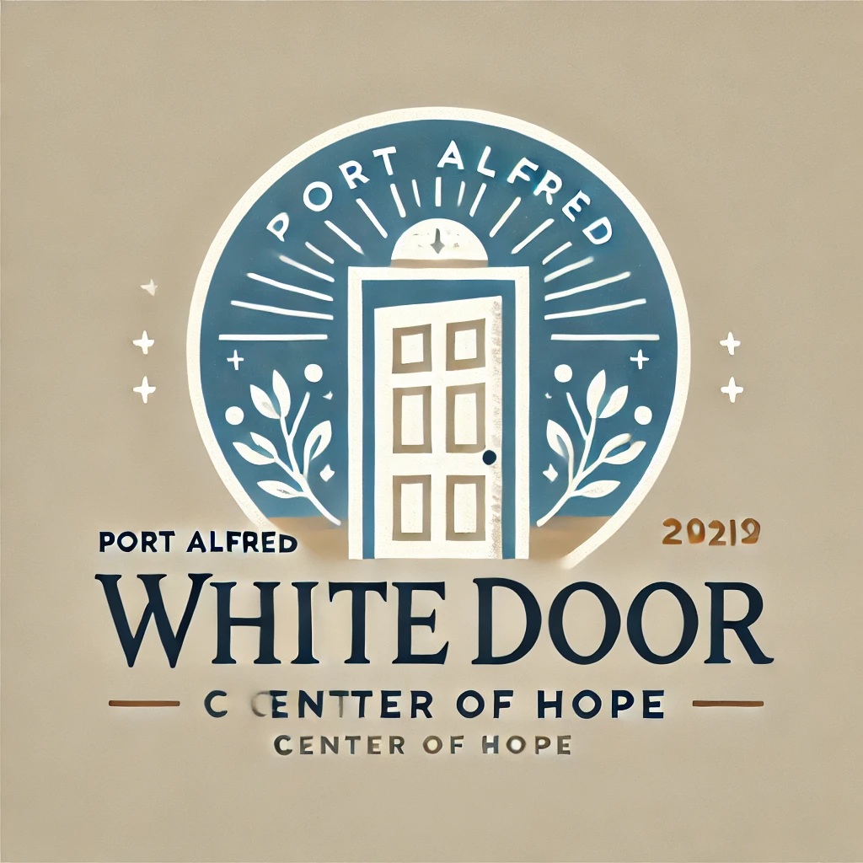

Image generated from ChatGPT

Table of Contents

Introduction 1

Website Goals and objectives 2

Estimated Budget 3

References 4

## Introduction

The Port Alfred White Door Centre of Hope is a non-profit organization (NPO) dedicated to providing shelter, support, and resources for individuals affected by domestic violence, abuse, and homelessness. Established in 2009, the centre has played a vital role in empowering survivors, offering counselling, legal aid, emergency housing, and skills development programs.

## Mission and Vision Statements

**Mission:**

To provide a safe haven, support services, and empowerment programs for survivors of domestic violence and vulnerable individuals, ensuring they have the resources to rebuild their lives.

**Vision:**

To create a community free from abuse, violence, and homelessness, where every individual feels safe, valued, and empowered to thrive.

## Target Audience

* Survivors of domestic abuse seeking support and shelter
* Homeless individuals in need of assistance
* Community members looking to contribute or volunteer
* Government agencies & social workers collaborating on relief efforts
* Donors & sponsors interested in supporting the cause

## Website Goals and Objectives

* The website will serve as a central hub for information, support, and engagement. Key goals include:
* Providing resources and support information for individuals in crisis
* Facilitating donations and fundraising initiatives
* Encouraging volunteer sign-ups and community engagement
* Enhancing awareness and education on domestic violence and homelessness
* Establishing an online presence for credibility and outreach

## Website Features and Functionality

* Home Page: Overview of the centre’s mission, impact stories, and emergency contact details.
* About Us: History, mission, vision, and leadership team.
* Get Help: Information on available services, emergency contact options, and FAQs.
* Donate Page: Secure payment integration for one-time and recurring donations.
* Volunteer Page: Sign-up form and upcoming volunteer opportunities.
* Resources & Blog: Articles, survivor stories, educational materials, and legal guidance.
* Events & Fundraisers: Calendar of upcoming charity events and fundraising campaigns.
* Contact Page: Inquiry form, location details, and helpline numbers.

## Design and User Experience

The website will feature a clean, modern, and accessible design, ensuring easy navigation and inclusivity.

Design Elements:

* Colour Scheme: Soft blues and warm neutrals to convey safety, trust, and hope.
* Typography: Readable, professional fonts such as Montserrat and Open Sans.
* Layout: Simple, structured design with clear call-to-action buttons.

User Experience Considerations:

* Mobile-Optimized & Responsive: Ensures accessibility across devices.
* Easy Navigation: Well-organized menus for quick access to resources.
* Fast Load Speeds: Optimized for performance and user retention.
* Accessibility Features: Text-to-speech, high-contrast mode, and large font options.

## Technical Requirements

* Domain & Hosting: Secure hosting with SSL certificate.
* Content Management System (CMS): WordPress for easy updates and scalability.
* Security & Privacy: Data encryption and compliance with protection laws.
* SEO Optimization: Ensuring the website ranks well on search engines.
* Integration: Secure payment gateway for donations and social media embedding.

## Estimated Budget

|  |  |
| --- | --- |
| **Expense Category** | **Estimated Cost** |
| Domain Registration & Hosting | R2 000 per year |
| Website Development | R20 000 once off |
| Content Management Services & Plugins | R8 000 |
| Security and Maintenance | R5 000 per year |
| Marketing and SEO | R15 000 |
| **Total Estimated Budget** | **R50 000** |

## References

1. Squarespace (2025) *squarespace.com*. <https://www.squarespace.com/> . (accessed 21 March 2025)
2. Companies and Intellectual Property Commission (2024) *Company fees and forms*. <https://www.cipc.co.za/?page_id=3804> (accessed 20 March 2025)
3. Open AI ChatGPT (2025). <https://chatgpt.com/> (accessed 10 March 2025)